**The following format, including title, font, columns, etc., is the requirement for manuscript, please browse carefully.**

**RESEARCH ARTICLE**

Journal of Global Humanities and Social Sciences

yyyy,Vol. xx(xx)1-3

DOI: 10.61360/BoniGHSSxxxxxxxxxxxx

**Article Title**

*Notes:The manuscript must include the following sections: Title, Abstract, Keywords, Introduction/Literature review, Main body, Summary, References; Adoption of Times new Roman font, size 10 and double-spaced.*

**Abstract:** All manuscripts must be in English, the abstract should be no more than 200 words, with no figures or tables, no references cited, and no comments or explanations. 3-5 keywords separated by semicolons. Choose words that relate to the core of the article and are independent and have real meaning.

**Keywords:** manuscripts; main content; copyright; English

**1. Introduction**

All manuscripts must be in English, also the table and figure texts, otherwise we cannot publish your paper.

The introduction should provide a context that gives the general reader a comprehensive understanding of the field and the research conducted. It addresses a problem and sets out its important aspects and the significance of the research. The introduction may conclude with a brief statement of the purpose of the work and a comment on whether that purpose has been achieved.

**2. Main Content**

**2.1. About heading**

Headings at all parts are clear and in the correct order. Please number all section headings, subheadings and sub-subheadings. Use boldface to identify major headings and subheadings. For the sub-subheadings, please distinguish it further as (1), (2), (3).

If your article has tables, figures or pictures, mention table 1 or figure 1 within the text. Please note that the content of the chart must be in English. All content is clearly displayed and correctly positioned; if there is a flowchart, the logic is clear and free of ambiguity; All figures and tables must be referred to in the text, such as the study is shown in **Table 1**. If your table is small, continue typing after the paragraph. If the table is large, adjust it to be presented in one column. Here is the format for tables and figures.

****Please do not fill in any information here****

**Figure1 Title**

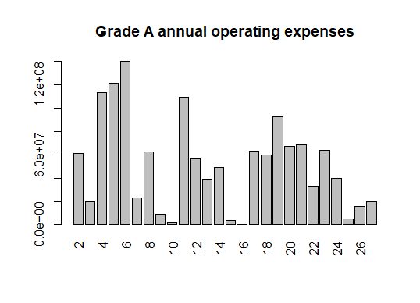

**2. 2. About references**

**2.2.1. Requirements for in-text citation**

Regarding in-text citations, Please standardize in-text citation format throughout the text.

(1) The **first in-text citation format**: please uniformly use the numerical numbering form to carry out sequential numbering in order, use the same number for the same reference, and marked it in blue in the text. For example:

1. Negotiation research spans multiple disciplines[1,2].

2. This result was later refuted by prof[3].

3. This effect has been extensively studied[1-3, 5].

(2) For the **second in-text citation format**, use

the APA7 format directly. For example:

1. Bayes algorithm has outstanding uncertainty expression ability and can make comprehensive use of prior knowledge and data sample information, so it is a common technical method for classification problems (Sinaga & Sinaga, 2020).

2. Farughi et al. (2016) took the financial indicators of listed companies as the research object, built a naive Bayes classifier as a stock selection method. 3. In recent years, with the development of big data technology, it has been widely used in personalized recommendation technology in e-commerce system, social system and we-media system (Fu et al., 2021).

**2.2.2. Requirements for post-textual references**

(1) At least 8 references, each of which must be mentioned in the text and labeled sequentially.

(2) No more than 3 citations, both self and other.

(3) References cited should be authoritative and original. There should be no more than 2 references of a web-based nature.

(4) Do not use footnotes or endnotes in place of a reference list. The reference list should include only citations in the text and works published or accepted for publication. Personal communications and unpublished works should be excluded from this section.

(5) For references in the reference list, all authors must be cited. All references should be numbered (e.g. [1]. [2]. [3]. etc.) and sorted in the order in which it appears as a text citation.

(6) Please indicate the reference format correctly according to the journal code.

**Conflict of Interest**

The authors declare that they have no conflicts of interest to this work.

**Acknowledgement**

This research was funded by:

authors should declare in this section all financial and non-financial support that may be considered a source of competing interests related to their submitted manuscript. If not, please delete this section.

**References**

**The following is a reference to the APA7 format.**

[1] Liu, Y., Li, H, ...., & Zheng, B. (2019). Risk identification method of guarantee circle combined with feature selection and logistic regression. *Minicomputer Systems*, *40*(8), 1781–1787.

[2] Yan, W., & Wu, W. (2009). *Data structure*. Tsinghua University Press.

[3] Sinaga, J., & Sinaga, B. (2020). Data mining classification of filing credit customers without collateral with k-nearest neighbor algorithm (case study: PT. BPR diori double). *Journal of Computer Networks, Architecture and High Performance Computing*, *2*(1), 89–102.

[4] Farughi, H., Alaniazar, S., & Mousavipour, S. hamed. (2016). An empirical study on customer risk management in banking industry: Applying k-means and RFM methods (evidence from two iranian private banks). *International Journal of Risk Assessment and Management*, *19*(4), 315–330.

[5] Fu, Z., Zhang, B., Ou, L., Sun, K., Sun, X., & Chen, N. (2021). Research on enterprise financial customer classification method and preference based on intelligent algorithm. *Wireless Communications and Mobile Computing*, *15*(1), 115–120.

[6] Shahbazi, F. (2020). Using decision tree classification algorithm to design and construct the credit rating model for banking customers. *IOSR Journal of Business and Management (IOSR-JBM)*, *21*(3), 123–130.

[7] Wang, B. (2016). *Multivariate statistical analysis and R language modeling*. Jinan University Press.

[8] Wang, M. (2017). *Bayesian statistical model and its application research*. Economic Science Press.

**How to Cite: xxxx**. Article name. *Journal of Global Humanities and Social Sciences*, xx(xx), 1-5.

https://doi.org/ 10.61360/BoniGHSSxxxxxxxx